FlowGen Support Handover
Team | FlowGen
Support Period | [08-08-2026 to 21-08-2026]
Second-line Support | Chris G

1. Summary
During our support rotation, we monitored Fabric pipeline runs, reviewed pipeline notifications, investigated failures, and escalated issues where required.
Two notable issues were identified:
- Sirius Refresh Pipeline Failure caused by a Bronze-to-Silver notebook failure.
- Fabric Capacity Issue caused by long-running Spark sessions consuming capacity.

2. Issues Encountered and Resolutions
Date | Issue | Likely Root Cause | Resolution | Escalated To
09/08/2026 &  10/08/2026 | additional_silver_1 and sirius_gold_refresh did not run. The bronze_to_silver pipeline failed while processing the party table (table_id = 8). | The party table had grown to approximately 78 million rows. Spark incorrectly estimated the table size and chose a Broadcast Join, attempting to load and distribute the large target table in memory. This exceeded Spark memory limits and caused the notebook to fail. | The join logic was updated to prevent the large target table from being broadcast. Spark settings were adjusted, stale statistics were corrected, and the solution was validated successfully in the development environment. | Chris G
11/08/2026 | Fabric capacity issue impacting reports and sessions | Spark notebook sessions remained active for approximately 16 hours with Auto Stop disabled, causing excessive Fabric capacity consumption. | Stopped inactive Spark sessions. Capacity usage gradually returned to normal levels. | Chris G

3. Issue Details
Issue 1: Sirius Refresh Pipeline Failure
What Happened?
The main sirius_refresh pipeline showed Succeeded, but:
- additional_silver_1 did not run
- sirius_gold_refresh did not run

Root Cause
A bronze_to_silver notebook failed while processing the party table (table_id = 8).
The party table had grown to approximately 78 million rows. Spark incorrectly estimated the table size and chose a Broadcast Join, attempting to load and distribute the large target table in memory. This exceeded Spark memory limits, causing the notebook execution to fail.
Outcome
The pipeline followed its failure-handling path:
Notebook Failure
↓
Send Notification
↓
Exit Early
Graphical Explanation:
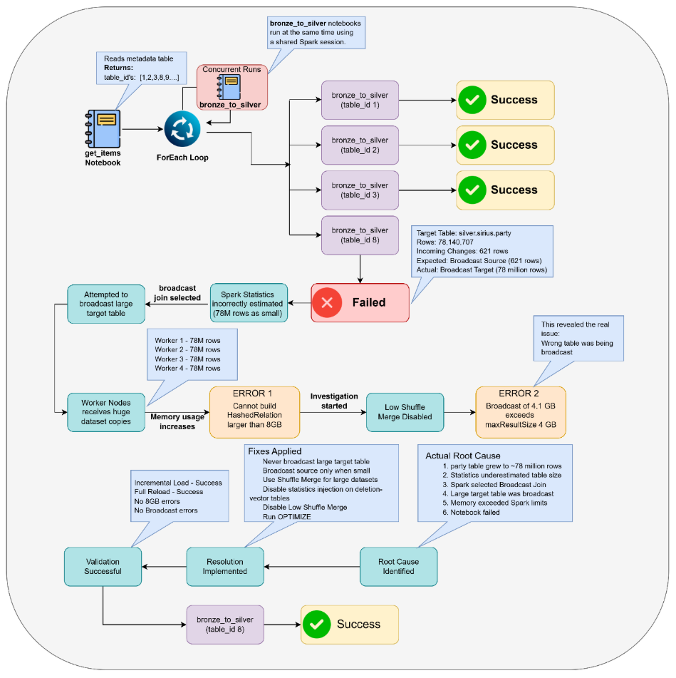

As designed:
- Additional Silver was skipped.
- Sirius Gold Refresh was skipped.
- The pipeline status still showed Succeeded because the failure notification process completed successfully.

Key Takeaway
A pipeline showing Succeeded does not always mean every notebook execution was successful. Always review the notebook activity runs and downstream pipeline executions when investigating pipeline issues.
How This Incident Helped Our Understanding
This investigation helped us understand:
- How the sirius_refresh pipeline works end-to-end.
- How get_items, ForEach, and bronze_to_silver work together.
- How Concurrent Runs allow multiple notebook executions to share a Spark session.
- Why a pipeline can show Succeeded even when a notebook has failed.
- How Broadcast Join decisions can affect Spark memory usage.
- Why downstream pipelines may not execute even though the parent pipeline shows Success.
- The importance of checking Monitoring Hub and activity runs instead of relying only on notifications.

Issue 2: Fabric Capacity Issue
What Happened?
Users experienced Fabric capacity-related issues, Inability to access report.

Root Cause
Two Spark notebook sessions remained active for approximately 16 hours.
The notebooks had Auto Stop Session disabled. As a result, the Spark sessions continued consuming Fabric compute capacity even when no work was being performed.
The prolonged consumption of capacity caused a significant capacity spike, leading to both interactive and background workload rejections across the Fabric environment.

Resolution
- Inactive Spark sessions were identified and stopped.
- Capacity consumption gradually reduced over time.
- Fabric capacity returned to normal operating levels.
- Interactive and background workloads resumed successfully.

Key Takeaway
Ensure notebook sessions are stopped when not in use and keep the Auto Stop Session setting enabled to prevent unnecessary Fabric capacity consumption and avoid capacity-related service disruptions
Note:
The issue was not caused by a notebook failure. The issue was caused by Spark sessions remaining active and consuming capacity while idle.

4. What We Learned
Monitoring & Investigation
- Instead of checking individual pipeline run histories one by one, it is more efficient to use Monitoring Hub to review all pipeline runs and activities from a single place before investigating specific runs.
- Always check the parent (invoking) pipeline as well as the downstream pipelines to understand the complete execution flow.
- Do not rely only on Teams notifications. Always verify the actual pipeline status and activity runs in Fabric Monitoring.
- A pipeline showing Succeeded does not always mean every activity or notebook succeeded. The pipeline may have followed a failure-handling path and still completed successfully.
- Missing downstream pipeline executions can sometimes be expected behavior if the pipeline exits early due to a failure condition.

Technical Learnings
- Concurrent Runs allow multiple notebook executions to run at the same time while sharing the same Spark session, helping reduce compute usage and improve execution time.
- The get_items notebook retrieves a list of table IDs, and the ForEach activity executes the same bronze_to_silver notebook for each table ID.
- A Broadcast Join can cause memory issues when Spark incorrectly treats a very large table as a small table and attempts to load it into memory.
- Large tables and incorrect join strategies can result in notebook failures even when the underlying data is valid.
- Spark worker node memory allocation plays an important role in notebook performance and stability.
- Long-running or idle Spark sessions can consume significant Fabric capacity and affect other workloads.

Reporting & Validation
- After verifying pipeline execution, review the reporting dashboard for abnormal results, failed checks, missing data, or unexpected changes.
- The sirius_gold_refresh pipeline currently does not send a success notification, so successful execution must be verified through the pipeline run history.

Pipeline Flow Explanation
The Sirius Refresh pipeline processes data from the Bronze layer to the Silver layer and then to the Gold layer. The pipeline is designed to stop early if any Bronze-to-Silver processing fails, preventing incomplete or incorrect data from flowing into later stages.

Step 1: Get Items
The pipeline starts by running the get_items notebook.
This notebook reads a metadata table and retrieves a list of table_ids that need to be processed.
Example:
table_id = 1
table_id = 2
table_id = 3
table_id = 8
table_id = 9

Whenever a new table needs to be ingested from Bronze to Silver, its details are added to this metadata table.

Step 2: ForEach Loop
The list of table_ids is passed into a ForEach activity.
The ForEach loops through every table_id and executes the same bronze_to_silver notebook for each table.
Example:
table_id 1 → bronze_to_silver
table_id 2 → bronze_to_silver
table_id 3 → bronze_to_silver
table_id 8 → bronze_to_silver
table_id 9 → bronze_to_silver

Step 3: Concurrent Runs
The pipeline uses a feature called Concurrent Runs.
This means multiple executions of the bronze_to_silver notebook can run at the same time instead of waiting for one another.

Example:
ForEach
----bronze_to_silver (table_id 1)
----bronze_to_silver (table_id 2)
----bronze_to_silver (table_id 3)
----bronze_to_silver (table_id 8)
----bronze_to_silver (table_id 9)

All of these notebook runs can start around the same time and share the same Spark session, which helps:
- Reduce compute costs
- Improve performance
- Complete processing faster
This is why multiple bronze_to_silver notebook runs may appear with the same start time in Monitoring.

Step 4: Bronze to Silver Processing
For each table, the bronze_to_silver notebook performs tasks such as:
Renaming, basic transformation, datatype change, etc
The goal is to prepare clean and validated data in the Silver layer.

Step 5: Check for Failures
After all Bronze-to-Silver notebook executions finish, the pipeline checks whether any of them failed.

Example:
table_id 1 ✅ Success
table_id 2 ✅ Success
table_id 3 ✅ Success
table_id 8 ❌ Failed
table_id 9 ✅ Success
The pipeline then evaluates whether there are any failures.
Step 6: If All Notebooks Succeed
If every bronze_to_silver notebook completes successfully:

Bronze to Silver Complete
↓
additional_silver
↓
sirius_gold_refresh
↓
Pipeline Complete
The pipeline continues normally to the Silver-to-Gold stage.

Step 7: If Any Notebook Fails
If even one bronze_to_silver notebook fails:

Bronze to Silver Failure
↓
Failure Detected
↓
Send Teams Notification
↓
Exit Pipeline Early

The pipeline does not continue to:
additional_silver
sirius_gold_refresh
This is exactly what happened on 09-Aug-2026 and 10-Aug-2026.
The bronze_to_silver notebook failed while processing the party table (table_id = 8). The table contained approximately 78 million rows, and Spark incorrectly selected a Broadcast Join strategy, causing excessive memory usage and notebook failure. As a result, the pipeline exited before reaching the Silver-to-Gold stage.

Step 8: Why the Pipeline Still Showed "Succeeded"
This can be confusing at first.
The pipeline is designed so that when a failure occurs:
Notebook Failure
↓
Failure Recorded
↓
Teams Notification Sent
↓
Pipeline Ends Gracefully
Since the failure-handling process completed successfully, Fabric marks the overall pipeline run as: Succeeded
even though one of the notebook executions failed.
Key Point to Remember
A Succeeded pipeline status does not always mean every notebook succeeded.
Always check:
- Pipeline activity runs
- ForEach executions
- Notebook run status
- Downstream pipeline executions
- Report execution

Recommendations for the Next Team
- Do not rely only on the Notification Group messages. Review all notifications received and verify them against the actual pipeline run history.
- Check the pipeline run history first. If a failure is reported, investigate the pipeline activities and notebook runs before reviewing reports.
- If all pipelines show as successful, check the invoking (parent) pipeline and confirm:
- It ran on the expected date.
- The latest run completed successfully.
- All required downstream pipelines were triggered.
- Validate notifications against actual execution results. Ensure the notification matches what is shown in the pipeline monitoring and run history.
- Review the reporting dashboard after pipeline validation. Look for any abnormal results, missing data, failed checks, or unexpected changes.
- Check known exceptions before escalating. Confirm whether the issue is an expected anomaly or a new failure requiring investigation.
- Note: sirius_gold_refresh has been modified and does not send a success notification. Therefore, the absence of a success notification does not necessarily indicate a failure. Always verify the pipeline run history directly.
- Escalate early if the root cause is unclear or if a rerun does not resolve the issue.
- Document all findings and resolutions to help improve future support handovers and troubleshooting.

